Step by step screenshots of working app:

Application ran successfully:

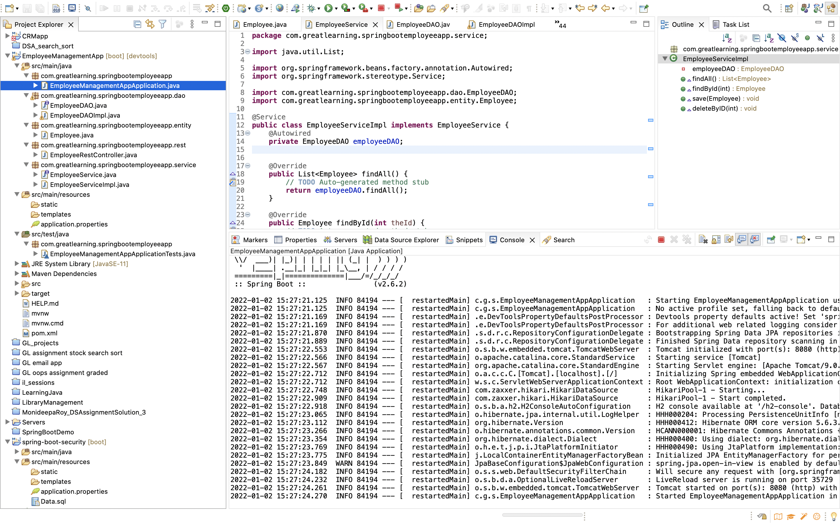

Used H2 in memory Database:

9. i.

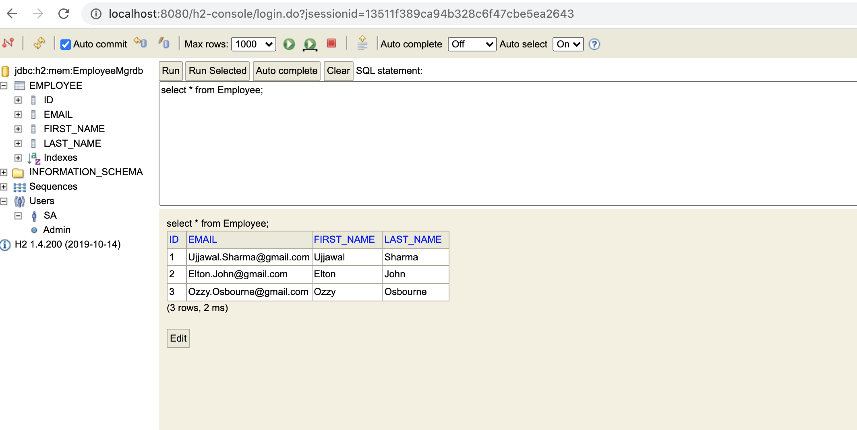

3. Add employee (POST)

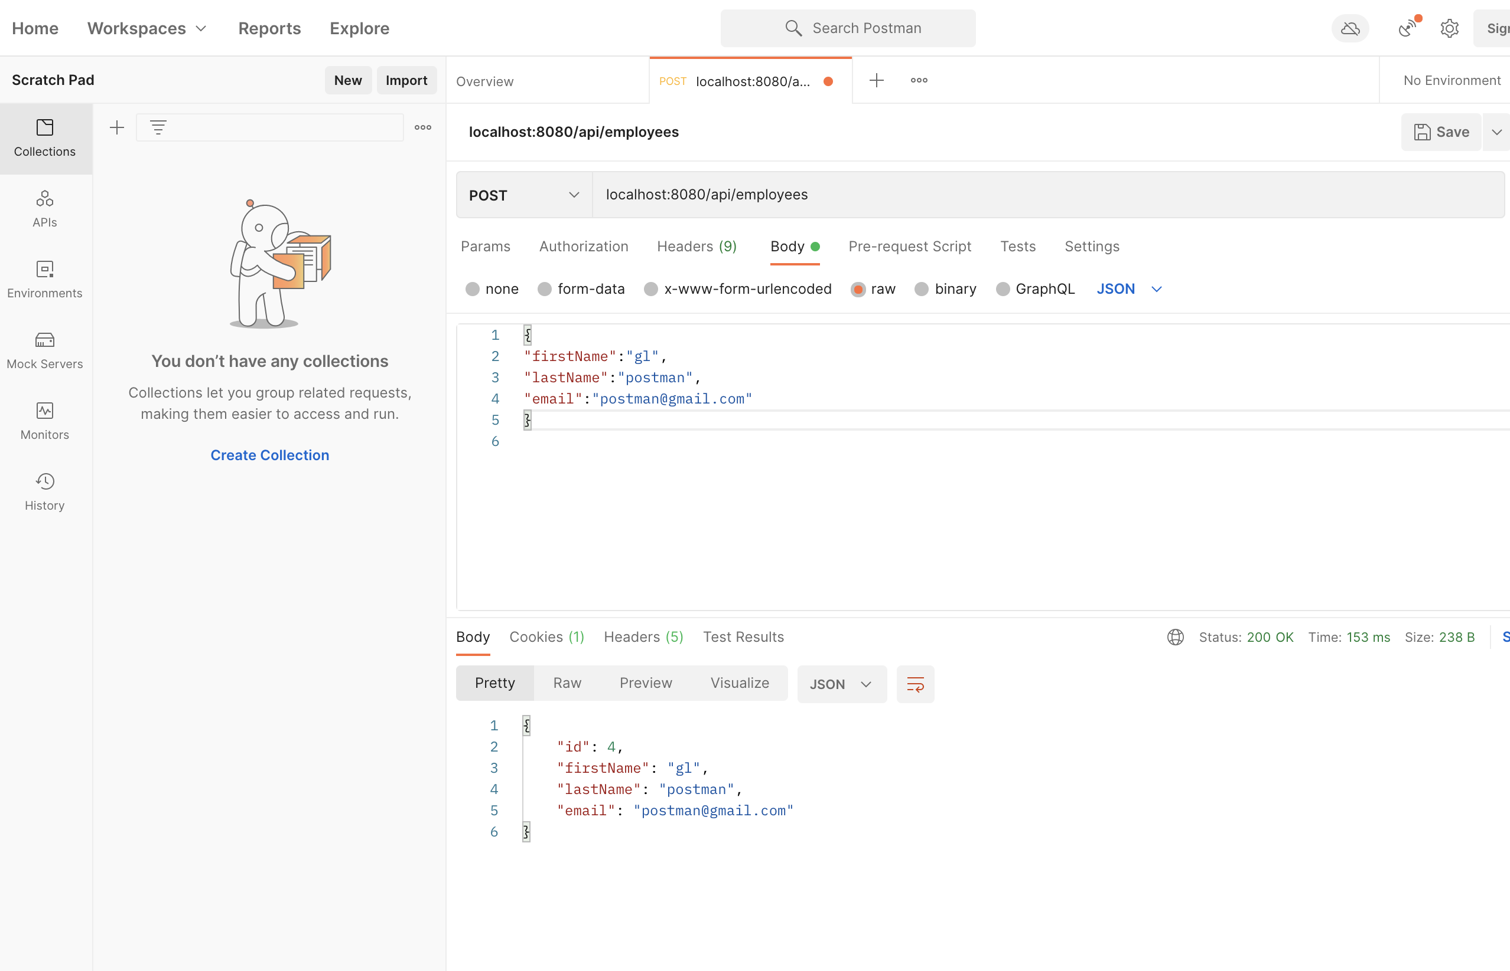

4. List all employees

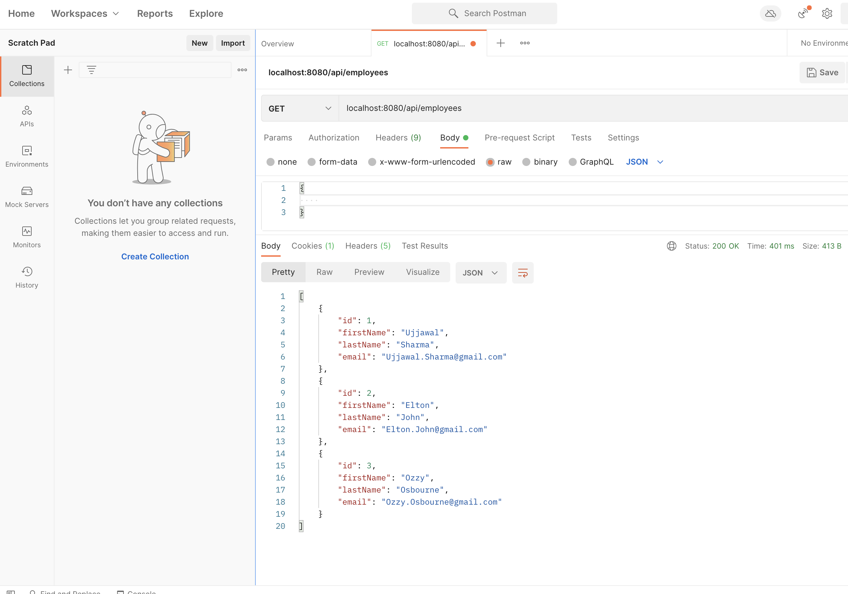

5. Fetch Employee by Id

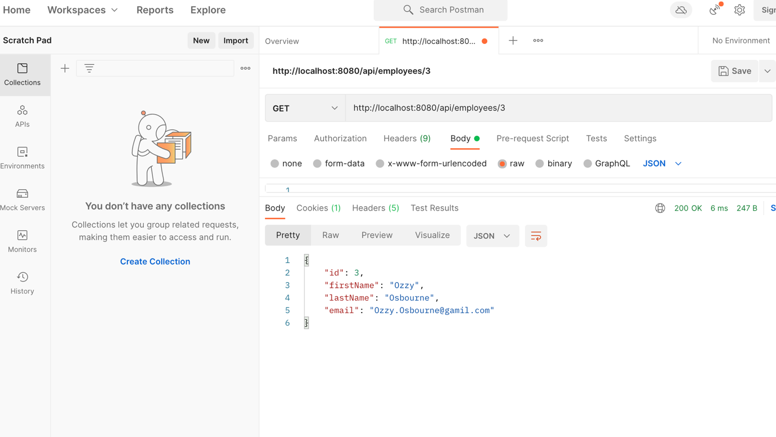

6.Update Employee

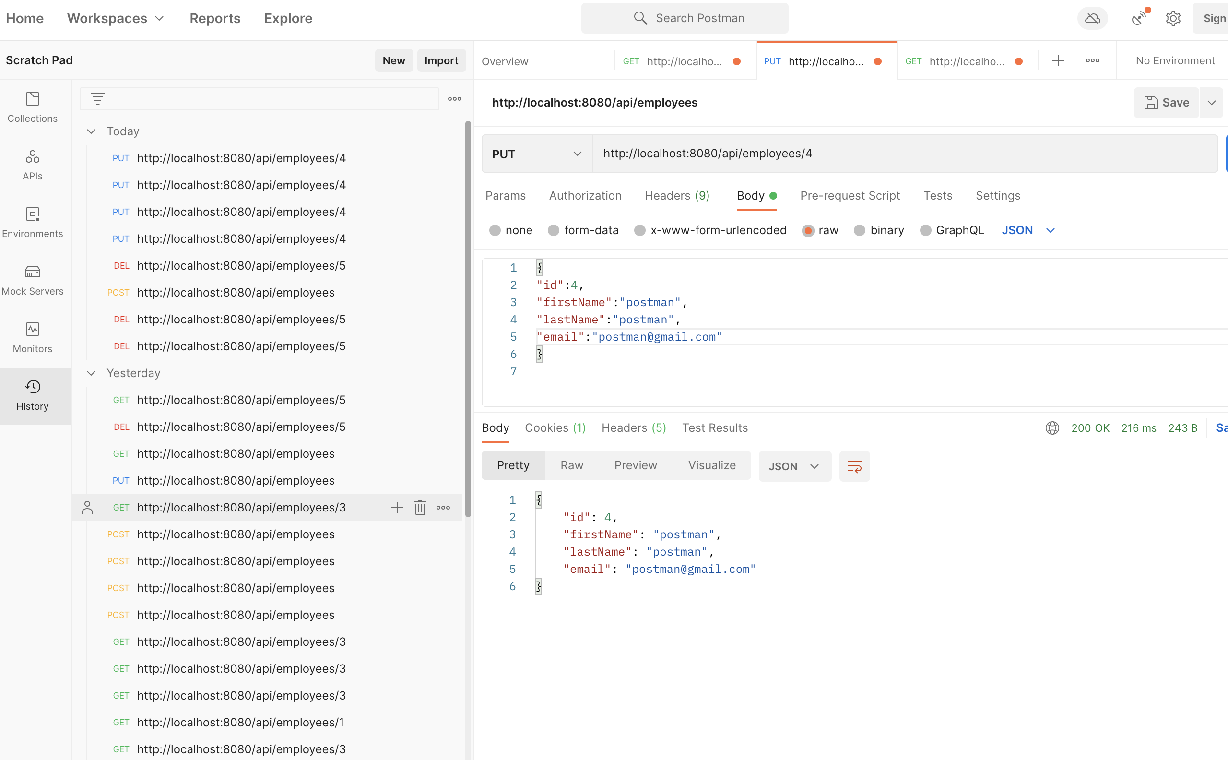

7. Delete Employee by id

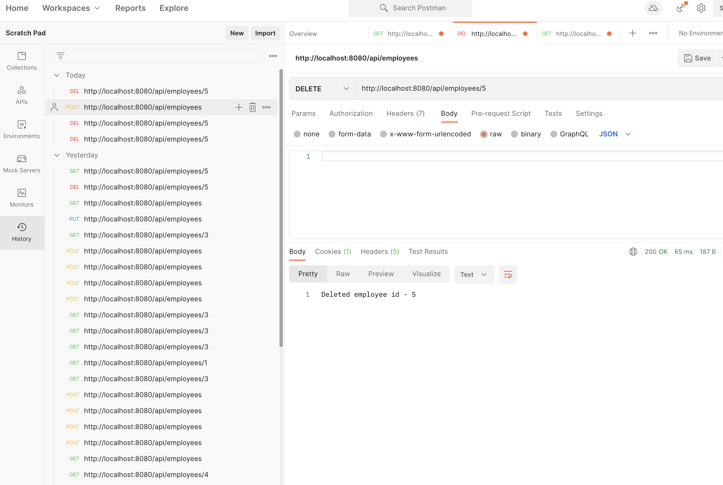

8. Search Employee by first name

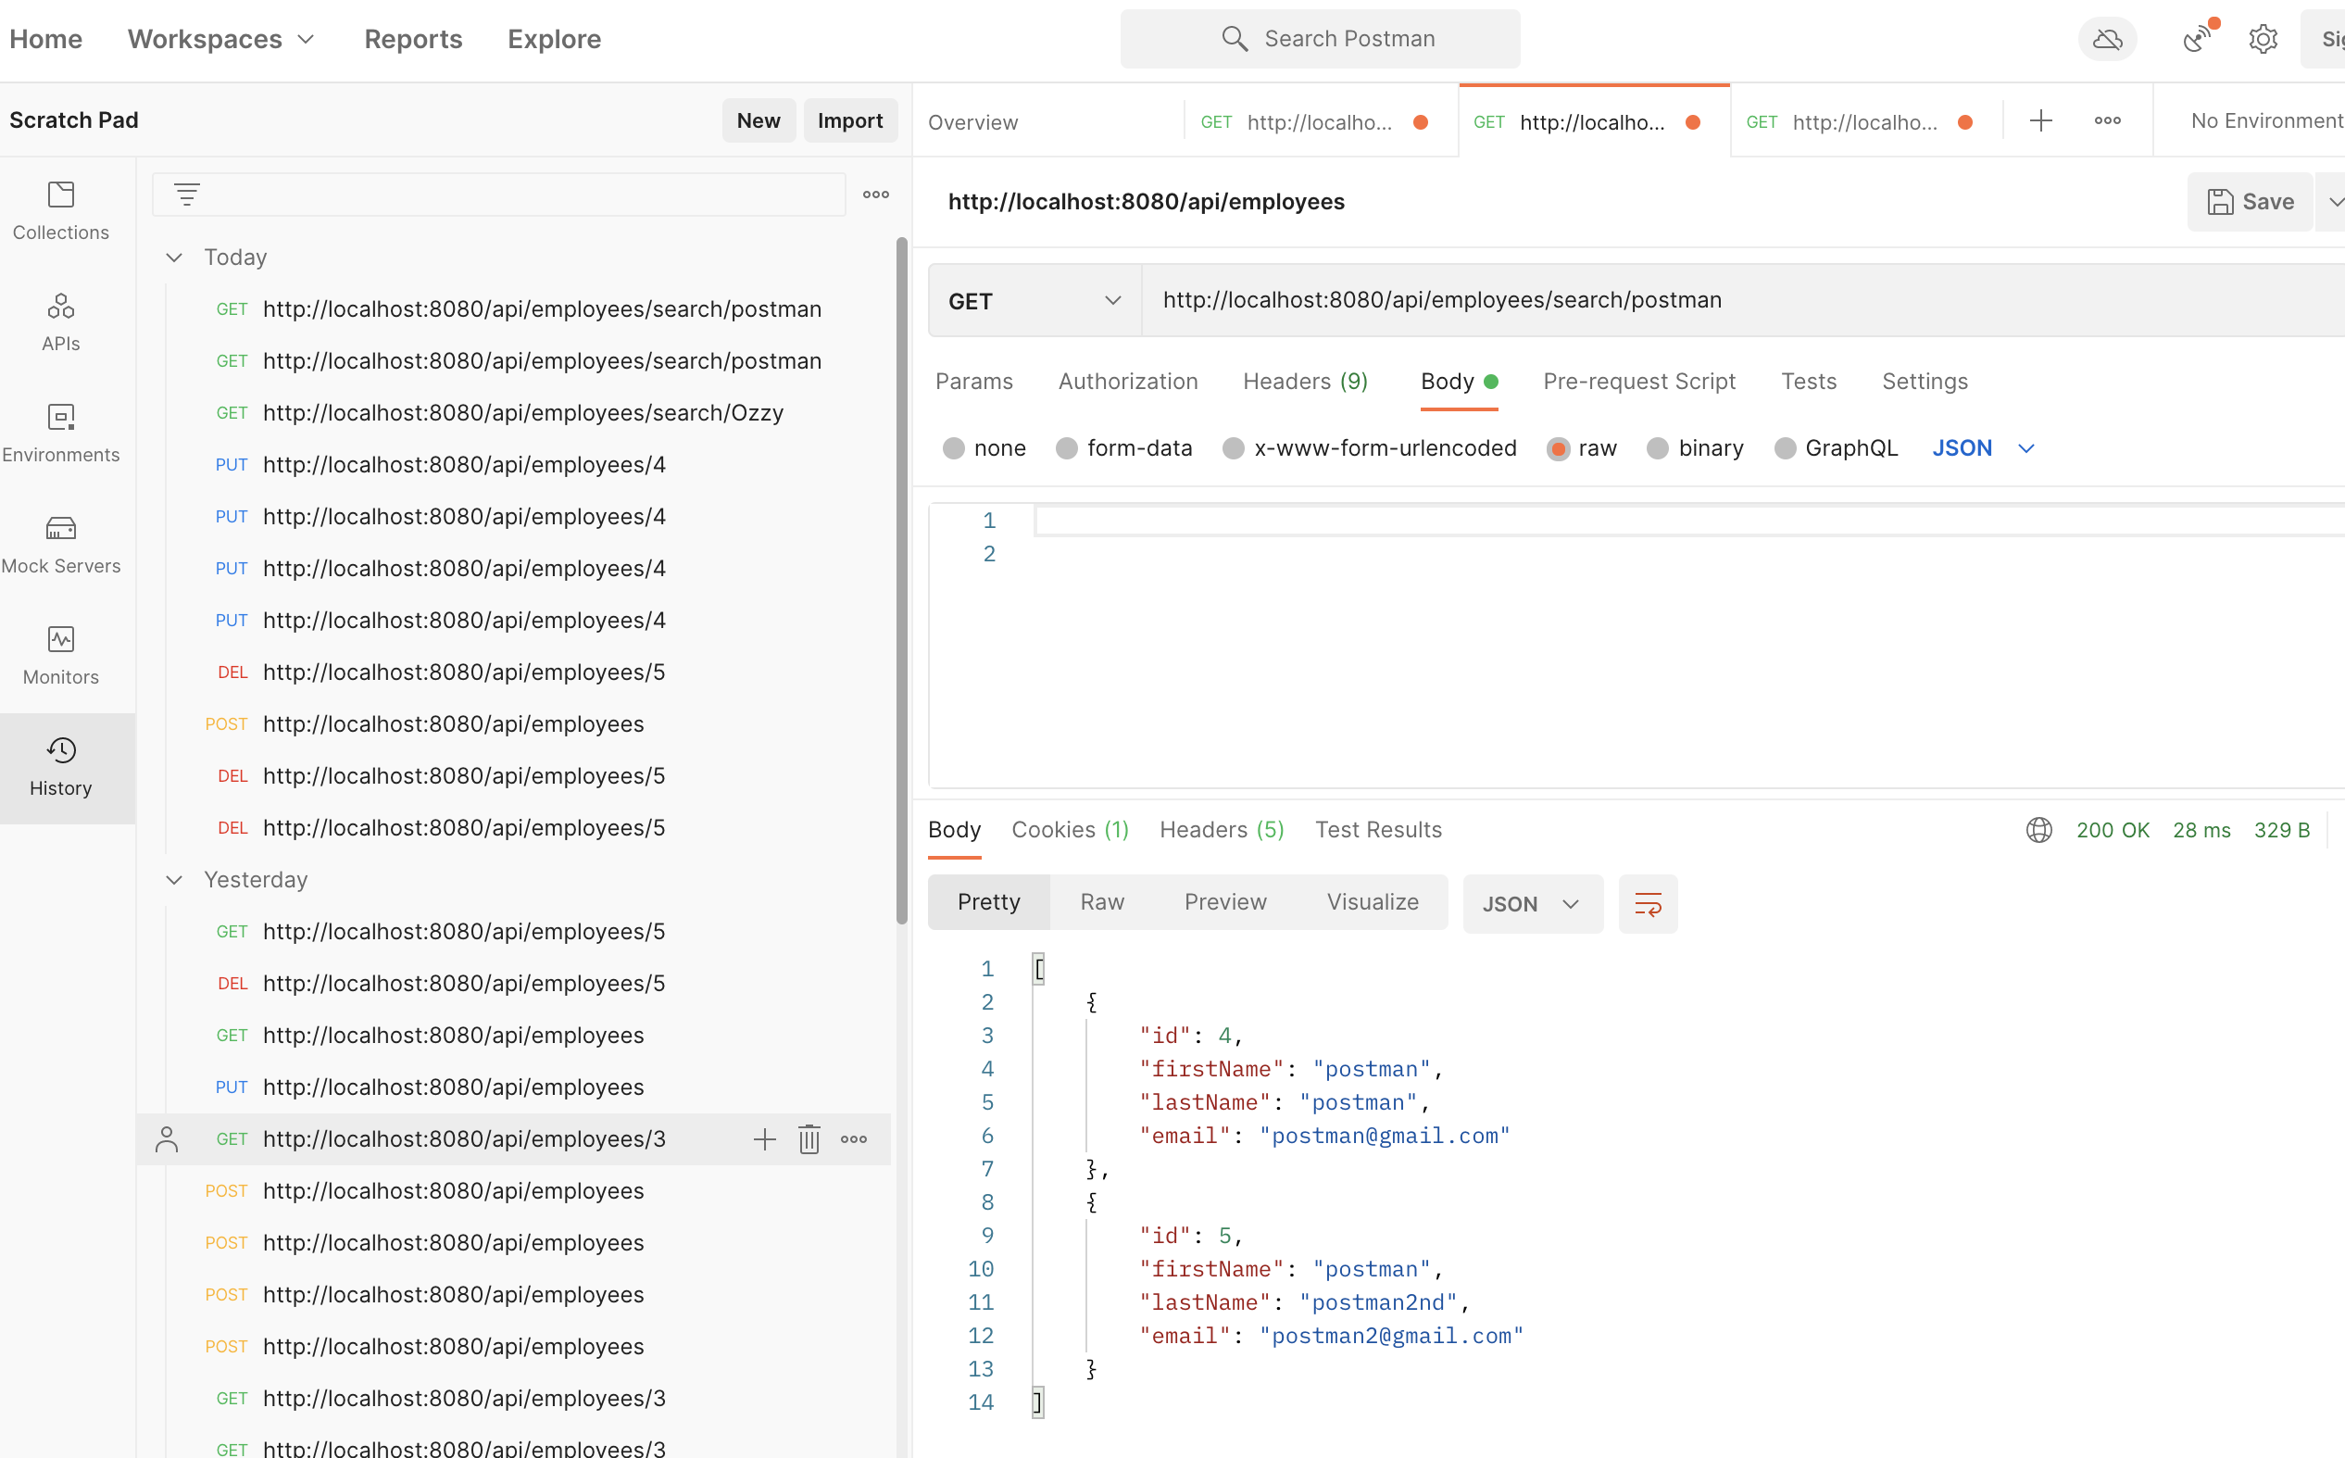

9. Sort Employee in specified order (desc)

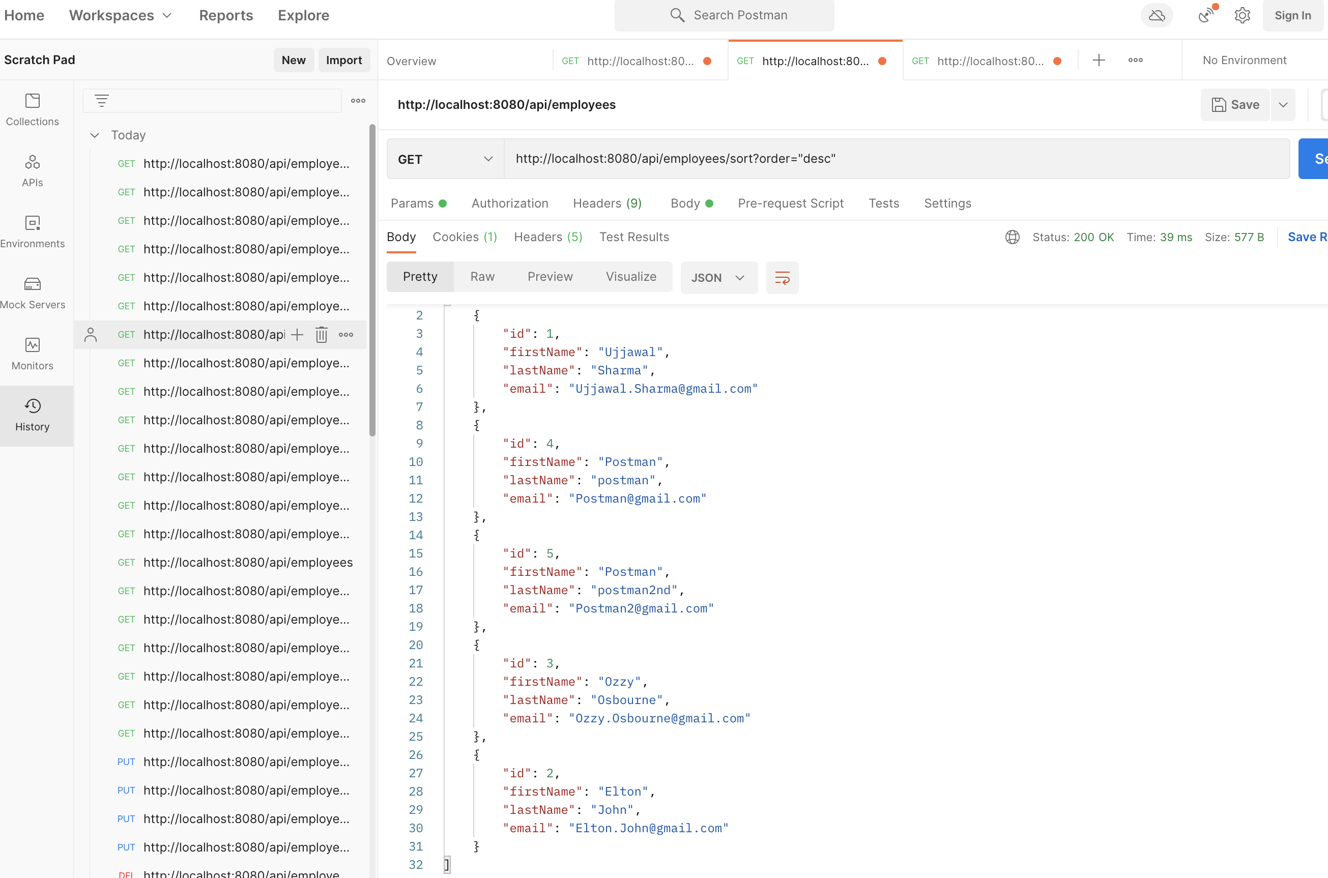

Spring Security:

With admin user, it permits accessing the endpoints

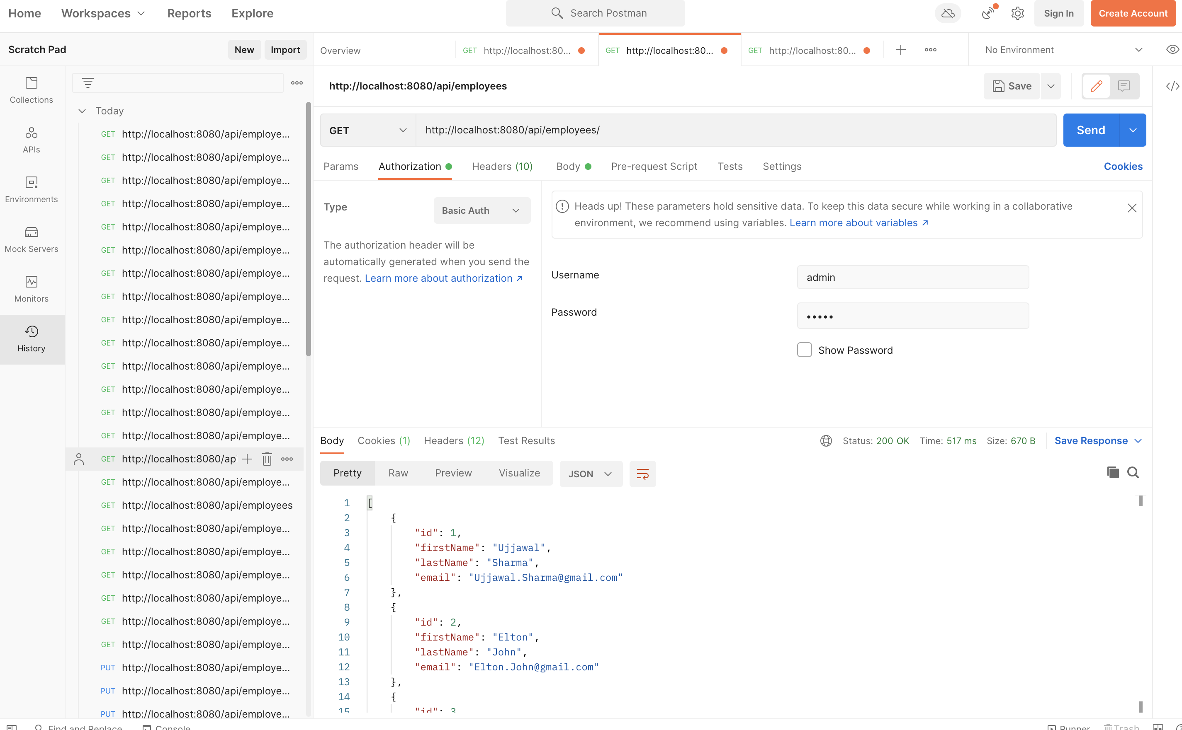

With any random user, it gives a 401 Unauthorized response.

